

Special Instructions / Other Print Info and Injection Sites for BCMA v3.0

RELEASE NOTES

PSB*3*68

September 2012

Department of Veterans Affairs
Product Development (PD)

Table of Contents

1. Introduction 1
2. Special Instructions/Other Print Info Enhancement 3
2.1. Virtual Due List (VDL) Modified 3
2.2. Three ways to display Special Instructions/Other Print Info on Each Medication Tab 3
2.3. Dialog Boxes Modified 5
2.4. Special Instructions/Other Print Info Pop-Up Boxes Modified 10
2.5. BCMA Cover Sheet Modified 10
2.6. BCMA Reports Modified 12
3. Injection Sites Enhancement 14
3.1. Conditions to enable Injection Site features 14
3.2. “Last Site” column displayed on the BCMA VDL 14
3.3. Options to Display Injection Site History 15
3.4. Injection Site History Dialog 16
3.5. Expanded Injection Site Needed Dialog 17
3.6. Multiple Administrations 19
4. Patient Safety Issue Corrections 19
5. Defect Fix for Remedy Tickets 20
6. New Service Requests (NSRs) Resolved 20
7. BCMA Online Help Update 20
8. Installation Details 20

Introduction

This document provides a feature summary of the Special Instructions and Other Print Info (SPECIAL INSTRUCTIONS/OTHER PRINT INFO) and Injection Sites functionality for Bar Code Medication Administration (BCMA) v3.0 project, patch PSB*3*68.

Installation instructions for PSB*3*68 are included in the patch description. See page 20 of these Release Notes for additional installation details.
- When installing PSB*3*68, a second part of the install will immediately begin running in the background and will create a new index for the injection site. This may take 20 to 30 hours to complete.
- After installing the patch, and upon opening BCMA, be sure to expand the last column which is entitled “Last Site.” The default is approximately 8 characters, depending on screen resolution, use of capitals or lower case, etc. After you expand the column, BCMA will remember the width each time you log in.

Patches PSB*3*58, PSB*3*61, PSB*3*62, PSS*1*171, PSJ*5*267 and PSB*3*67 must be installed prior to PSB*3*68.

Highlights
- The following dialogs and popups that include Special Instructions/Other Print Info were widened and modified to accommodate unlimited text sent via Inpatient Medications.
  - Special Instructions/Other Print Info pop-up boxes
  - Medication Log
  - Unable to Scan
  - Multiple/Fractional Dose
  - PRN Medication Log
  - PRN Effectiveness Log
  - Scan IV
- Title bar for Special Instructions/Other Print Info modified.
- Three methods added to display Special Instructions/Other Print Info on demand for each medication tab.
- New methods added to display Special Instructions/Other Print Info from the Cover Sheet.
- Last Site Column added to the VDL showing the location of the last injection site for the orderable item.
- Expanded Injection Site Needed dialog displays during administration of applicable medications, showing injection site history to assist with injection site rotation.
- Injection Site History dialog added showing the previous injection sites, up to 4, for the orderable item and all injection sites for the patient within the time frame for the parameter selected.
BCMA Reports
- All reports that contain Special Instructions/Other Print Info were modified to accommodate unlimited text.
- The report dialog boxes of some of the BCMA reports were modified to allow the user to include/exclude Special Instructions/Other Print Info from the reports.
Patient Safety Issue Correction
- Patient Safety Issues, PSPO 42, 1466, and 2037 resolved with PSB*3*68.
BCMA Online Help System Update
- The Online Help system has been updated for BCMA.

Special Instructions/Other Print Info Enhancement
Inpatient Medications and BCMA Special Instructions/Other Print Info fields were modified to support an unlimited amount of text. This text is received from the Provider Comments that are entered in the Computerized Patient Record System (CPRS) order entry screen by the provider, and then optionally edited by the Pharmacist in Inpatient Medications. Previously, the Inpatient Medications character length for Special Instructions was 180 characters and for Other Print Info 60 characters.

Virtual Due List (VDL) Modified
Special Instructions/Other Print Info will display on the VDL under the Active Medication. If the total height of the administration row including Special Instructions/Other Print Info is equal to or greater than 19 lines, the following message displays for all three med tabs in place of Special Instructions/Other Print Info (bold red text): “Too much information to display. Use right-click menu to display full text.”

Example: VDL Display
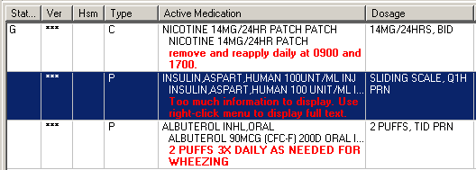

Three ways to display Special Instructions/Other Print Info on Each Medication Tab
The following three ways will display Special Instructions/Other Print Info for orders that contain them.

- Special Instructions/Other Print Info Right Click Menu
Example: Special Instructions/Other Print Info Right Click Menu
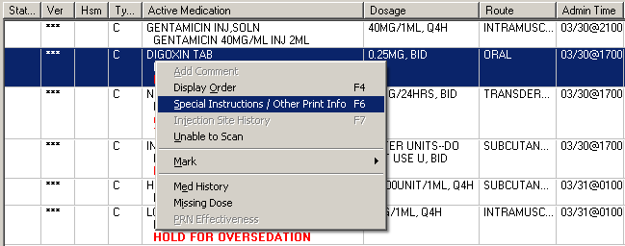

- Special Instructions/Other Print Info Due List Menu
Example: Special Instructions/Other Print Info Due List Menu
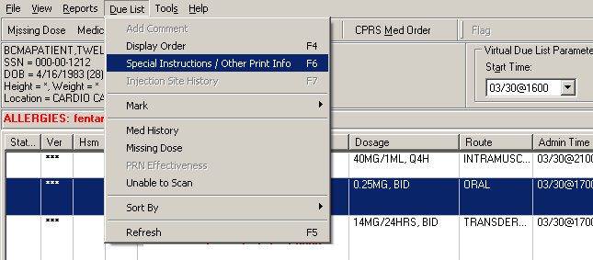

- Special Instructions/Other Print Info Shortcut Function Key (F6)
Example: Special Instructions/Other Print Info Shortcut (F6)
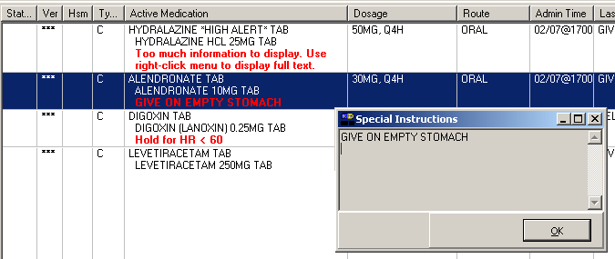

- The above options will be disabled (grayed out) for orders that do not contain Special Instructions/Other Print Info.
Example: Special Instructions/Other Print Info Disabled
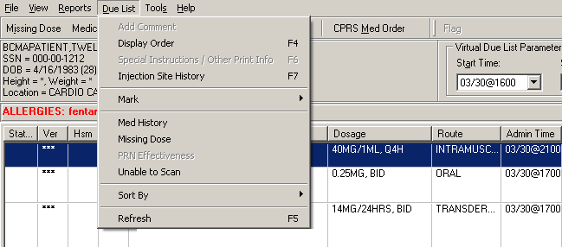

Dialog Boxes Modified
The following dialog boxes were modified by allowing the Special Instructions/Other Print Info box to expand the full width of the dialog box. A conditional vertical scroll bar and word wrap were added. The vertical height of the Special Instructions/Other Print Info display within the dialog boxes is 6 lines.

- Unable to Scan Dialog
Example: Unable to Scan Dialog
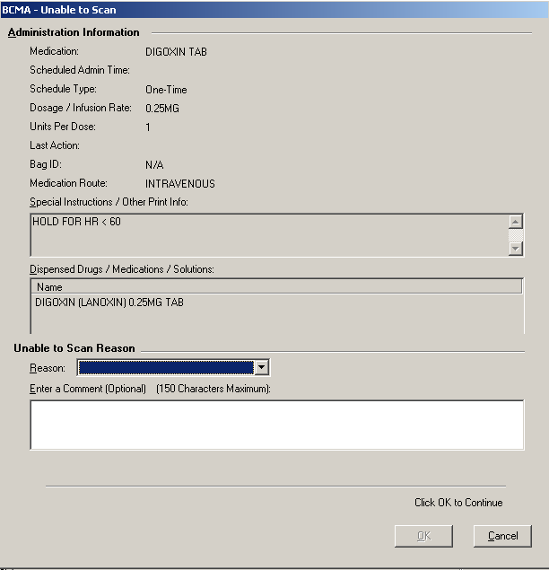

- Medication Log Dialog
Example: Medication Log Dialog
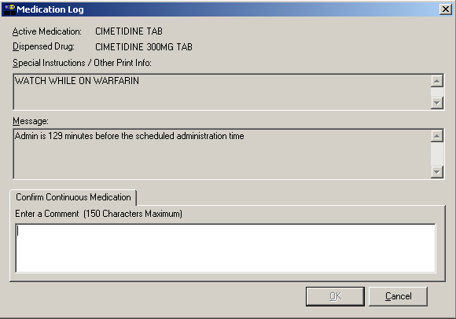

- Multiple/Fractional Dose Dialog
Example: Multiple/Fractional Dose Dialog
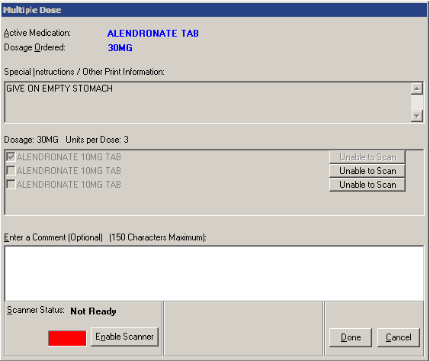

- PRN Medication Log Dialog
Example: PRN Medication Log Dialog
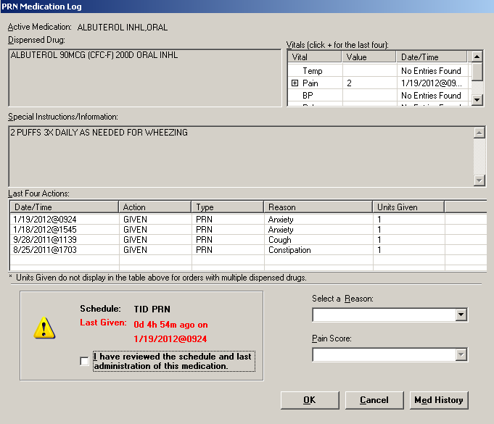

- PRN Effectiveness Log Dialog
Example: PRN Effectiveness Log Dialog
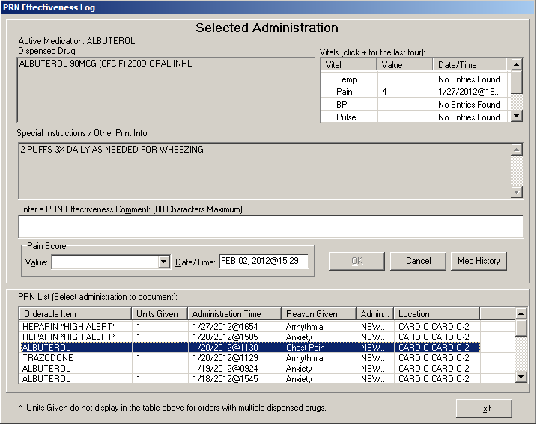

- Scan IV Dialog
Example: Scan IV Dialog
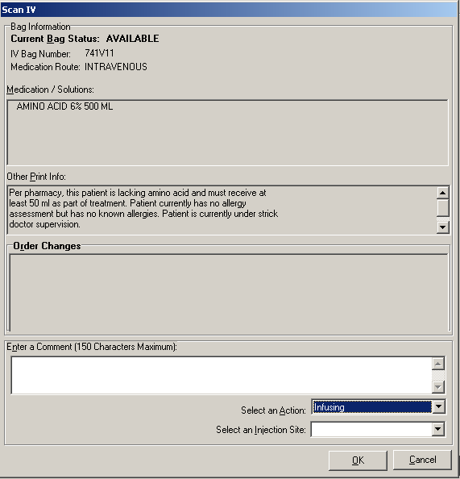

In all of the above dialog boxes, if Special Instructions/Other Print Info text exceeds 6 lines, a scroll bar and “Display Instructions” button appear. The following message displays in bold red text: “<Scroll down or click ‘Display Instructions’ for full text>.” When the “Display Instructions” button is clicked, Special Instructions/Other Print Info will display in the pop-up.

Following are examples of dialog boxes with Special Instructions/Other Print Info text that exceed 6 lines.
Example: Unable to Scan Dialog Box
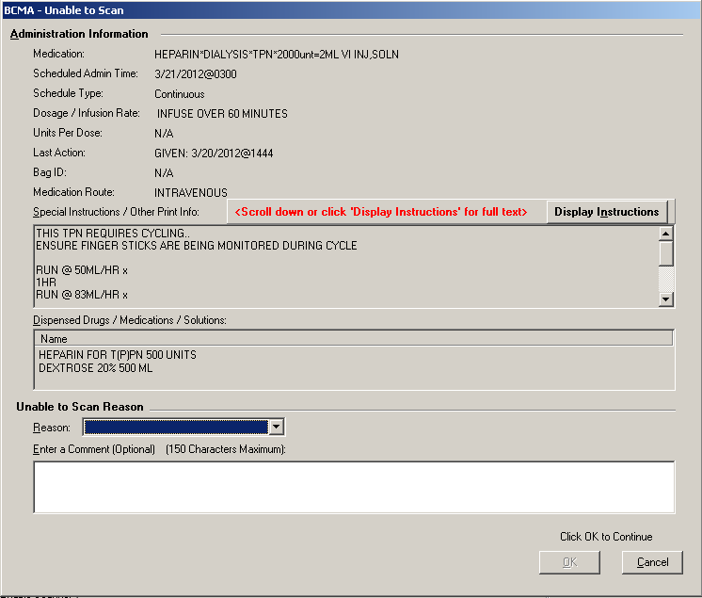

Example: Scan IV Dialog Box
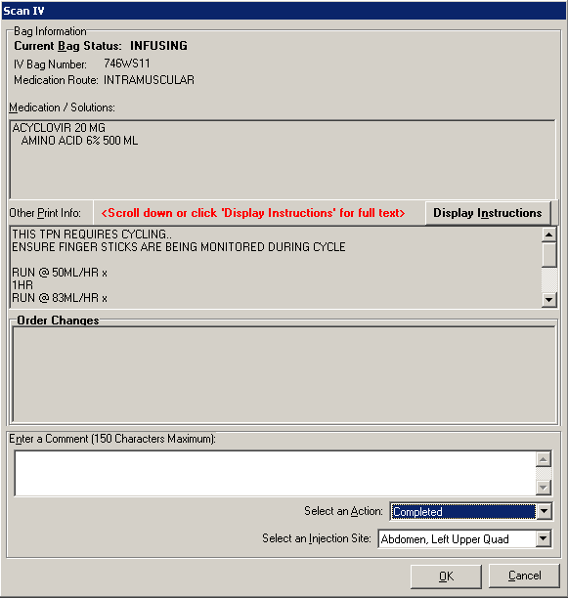

Special Instructions/Other Print Info Pop-Up Boxes Modified
- The title bar of the pop-up for Special Instructions/Other Print Info now reflects the type of information contained in the dialog, Special Instructions or Other Print Info. Special Instructions displays for Unit Dose and IV Push administrations, while Other Print Info display for IVPB and large volume IV medications.
- The default size of the Special Instructions pop-up box is approximately 80 characters wide with a minimum height of 6 lines. The width cannot be changed, and the height will automatically resize to accommodate the length of the message. If the vertical height of the message exceeds the size of the screen, a vertical scroll bar displays.

If the total height of the administration row, including Special Instructions, is equal to or greater than 19 lines, the following message displays in place of Special Instructions (bold red text): “Too much information to display. Use right-click menu to display full text.”

Example: Special Instructions Pop-up Box
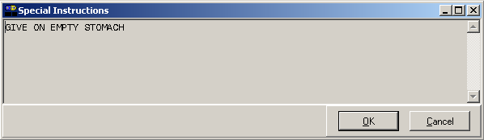

Example: Other Print Info Pop-up Box
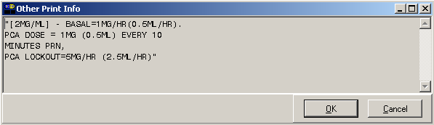

BCMA Cover Sheet Modified
- For orders containing Special Instructions/Other Print Info that exceed 180 characters on the Cover Sheet, the message: “Too much information to display. Use right-click menu to display full text” will be displayed.

Example: BCMA Cover Sheet
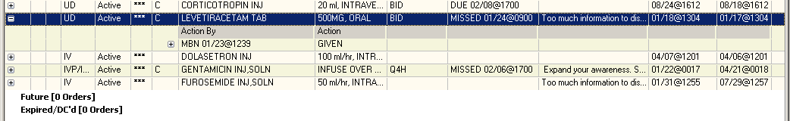

- For orders containing Special Instructions/Other Print Info that exceed 180 characters on the Cover Sheet, the hover text message: “Too much information to display. Use right-click menu to display full text” will be displayed while hovering over a Special Instructions/Other Print Info field exceeding 180 characters.

Example: BCMA Cover Sheet Hover Text
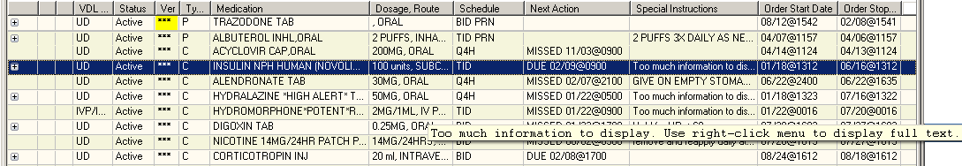

- The following two methods will also display Special Instructions/Other Print Info on the Cover Sheet.
  - Special Instructions/Other Print Info Right Click Menu

Example: Special Instructions/Other Print Info Right Click Menu
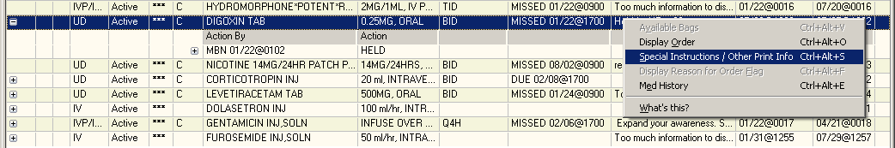

  - Special Instructions/Other Print Info Shortcut Key (Alt+Ctrl+S)

Example: Special Instructions/Other Print Info Shortcut Key (Alt+Ctrl+S)
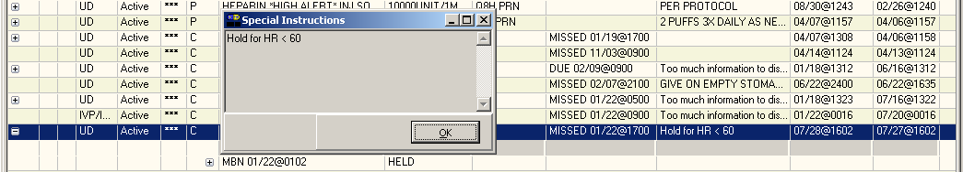

- The above options will be disabled (grayed out) for orders that do not contain Special Instructions/Other Print Info.

Example: Special Instructions/Other Print Info Disabled
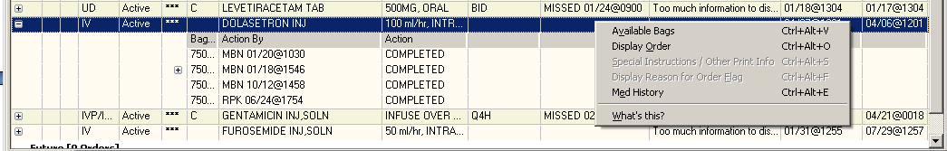

BCMA Reports Modified
The following BCMA reports were modified to invoke a 74 character word wrap for Special Instructions/Other Print Info to accommodate unlimited text.

- Medication Administration History (MAH) Report
- Display Order Detail Report
- Due List Report
- IV Bag Status Report
- Cover Sheet Report – Medication Overview Report
- Cover Sheet Report – PRN Overview Report
- Cover Sheet Report – IV Overview
- Cover Sheet Report – Expired/DC’d/Expiring Report

When printing the MAH report to a printer, if Special Instructions/Other Print Info need to flow to another printed page, a blank line with the message: “CONTINUED ON NEXT PAGE***” is printed before the page break. The message: “***CONTINUED FROM PREVIOUS PAGE ***” and a blank line is printed on the subsequent page after the page headers.

Special Instructions was moved below the Initials field and starts on a separate line to allow for wrapping and unlimited text. The field is now entitled “Special Instructions.”

Example: MAH Report
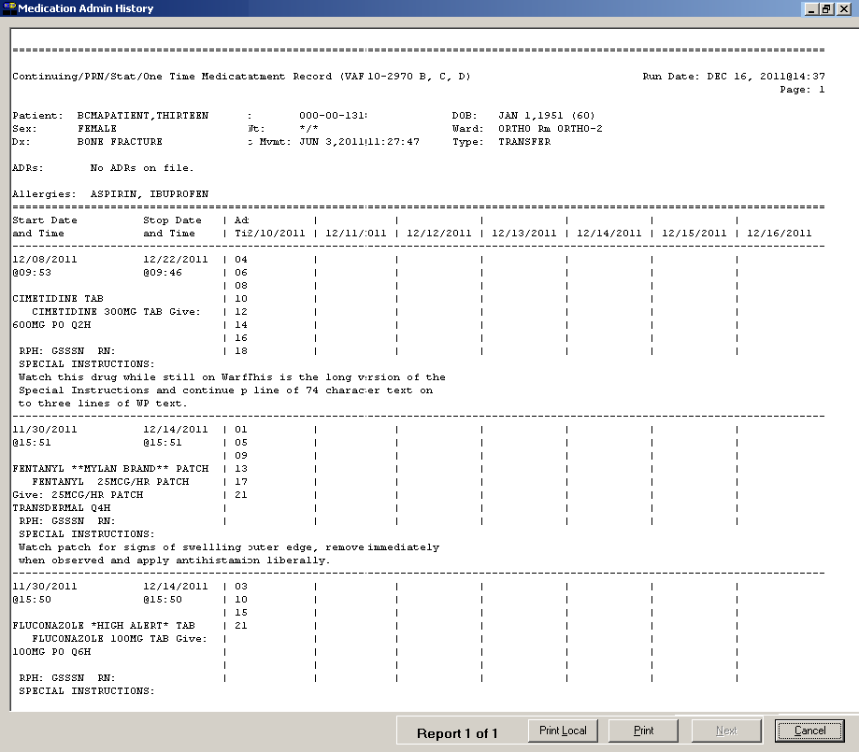

The report dialog boxes of the following BCMA reports were also modified to display a checkbox that allows the user to include/exclude SPI/OPI from the reports. The checkbox is unchecked by default, which excludes Special Instructions/Other Print Info from the reports.

- Due List Report
- IV Bag Status Report
- Cover Sheet Report – Medication Overview Report
- Cover Sheet Report – PRN Overview Report
- Cover Sheet Report – IV Overview
- Cover Sheet Report – Expired/DC’d/Expiring Report

Injection Sites Enhancement
BCMA now allows the nurse at the time of medication administration to see the location of up to the last four injection sites for the orderable item, displayed without time limits and all injection site entries for the patient within the time frame (nn) specified by the BCMA Site Parameter, “Injection Site History Max Hours.” The default is 72 hours.

Conditions to enable Injection Site features
The new injection site functionality applies to injectable administrations that participate in injection site rotation. When the following conditions are met, the Last Site column will be populated, Injection Site History options will be enabled, and the expanded Injection Site Needed dialog will display for applicable administrations.

Unit Dose Tab:
If the administration is on the Unit Dose Tab, and
“PROMPT FOR INJ SITE IN BCMA” = YES
in the Medication Routes file (#51.2).

IVP/IVPB Tab:
If the administration is on the IVP/IVPB tab, and
IV TYPE = SYRINGE, subtype INTERMITTENT or
IV TYPE = CHEMOTHERAPY, subtype SYRINGE, subtype INTERMITTENT, and
MEDICATION ROUTE = Intramuscular, Subcutaneous, or Intradermal, and
“PROMPT FOR INJ SITE IN BCMA” = YES, and
“DISPLAY ON IVP/IVPB TAB IN BCMA?” = YES
in the Medication Routes file (#51.2).

“Last Site” column displayed on the BCMA VDL
A new column, “Last Site”, was added to the VDL on the Unit Dose and IVP/IVPB tabs, displaying the last injection site that was indicated for the orderable item, for administrations that participate in injection site rotation. The column appears in the last position to the right of the “Last Action” column.

Example: Last Site Display
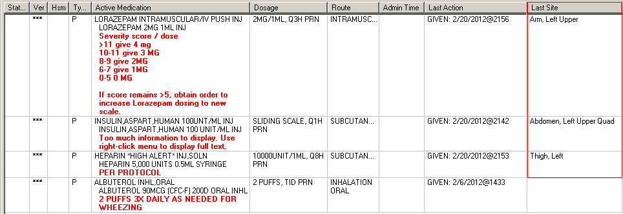

Options to Display Injection Site History
BCMA provides multiple ways to display Injection Site History for administrations that participate in injection site rotation.

- Right-click menu option, “Injection Site History”.
Example: Right-Click Menu
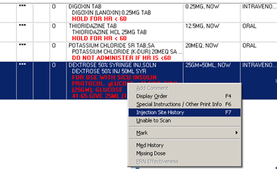

- Due List menu option, “Injection Site History”.
Example: Due List Menu
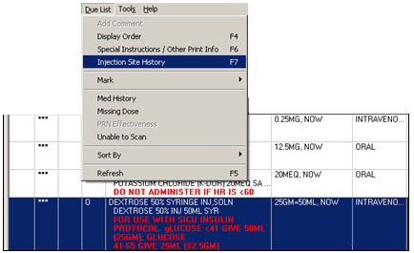

- F7 shortcut option enabled.

Injection Site History Dialog
The Injection Site History Dialog displays two tables:

- “Previous Injection Sites for this Medication (up to 4)” shown at the top, lists the last four injection sites for the orderable item displayed without time limits. The name of the Orderable Item and the route are shown above the top table.
- “All Injection Sites (within last nn hours)” shown at the bottom, lists all injection site entries for the patient within the time frame (nn) specified by the BCMA Site Parameter, “Injection Site History Max Hours.” The default is 72 hours.
Note: If no data exists for the table, the message “<<No data to display>>” appears.
The following fields are displayed in each table: Date Time, Medication (orderable item name), Dosage Given, Route, and Injection Site – sorted in reverse date/time order.

Example: Injection Site History Dialog
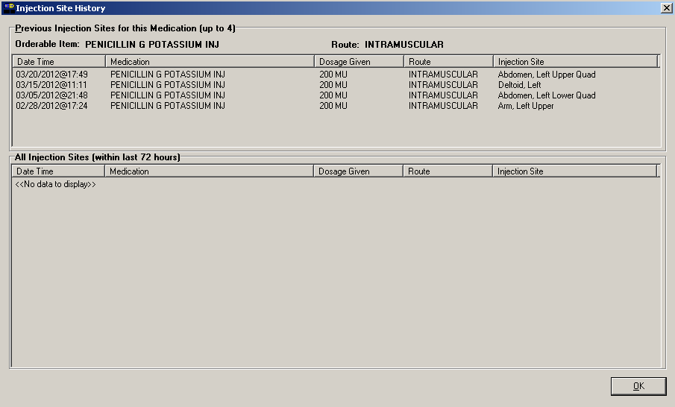

Expanded Injection Site Needed Dialog
The expanded Injection Site Needed displays during administration of injectable medications when the conditions in section 3.1 are met. The information provided in the following tables will assist the nurse in deciding the location of the next injection site, to ensure proper injection site rotation.

- “Previous Injection Sites for this Medication (up to 4)” shown at the top, lists the last four injection sites for the orderable item displayed without time limits. The name of the Orderable Item and the route are shown above the top table.
- “All Injection Sites (within last nn hours)” shown at the bottom, lists all injection site entries for the patient within the time frame (nn) specified by the BCMA Site Parameter, “Injection Site History Max Hours.” The default is 72 hours.
Note: If no data exists for the table, the message “<<No data to display>>” appears.
The following fields are displayed in each table: Date Time, Medication (orderable item name), Dosage Given, Route, and Injection Site sorted in reverse date/time order.

On the Unit Dose tab:
- The user selects the location on the patient where the medication is to be injected from the Select Injection Site drop-down list.
- Click OK.

Example: Expanded Injection Site Needed Dialog on Unit Dose Tab
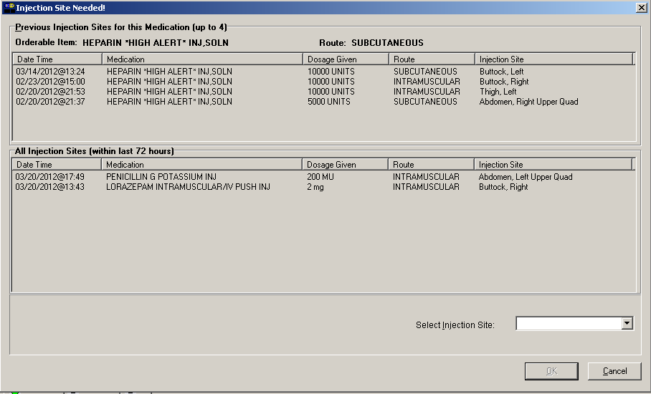

On the IVP/IVPB tab:
- In the lower left of the following dialog, a checkbox is displayed with the statement: “I acknowledge this medication to be administered via route:___________.” The medication route is displayed in bold uppercase red text. The OK button remains disabled until the user confirms the acknowledgement statement by checking the checkbox and selecting an injection site.
- The user selects the location on the patient where the medication is to be injected from the Select Injection Site drop-down list.
- Click OK.

Example: Expanded Injection Site Needed Dialog on IVP/IVPB Tab
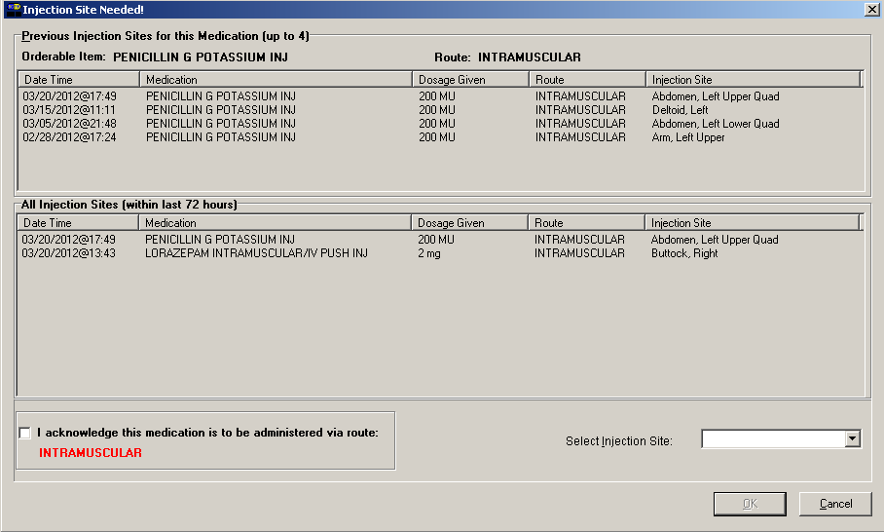

Multiple Administrations
When multiple administrations are selected, the Injection Site History menu option and corresponding F7 hotkey are disabled (grayed out) on both the Right click menu and the Due List Menu.

Patient Safety Issue Corrections
The following Patient Safety Issue corrections made with this patch:
- PSPO 42 – Special Instructions/Other Print Info too short corrected.
- PSPO 1466 – Provider Comments truncated when copying to Special Instructions corrected.
- PSPO 2037 – Unable to view all allergies/ADRs for patient on BCMA GUI corrected.

Defect Fix for Remedy Tickets
The following Remedy Tickets were resolved with this patch:
- HD480879 – Multiple Dose Dialog Box “Invalid Medications” popup modified to display whenever an invalid dose is scanned.
- HD488494 – BCMA modified to display all Allergies and ADRs for patients with more than one line of Allergies and ADRs.
- HD506938 – BCMA modified to always display Patient Record flag in Red.
- HD419658 – Special Instructions modified to print in full on Med Overview and PRN Overview Reports

New Service Requests (NSRs) Resolved
The following NSRs were resolved with this patch:

- 20031205 – Equalizing character limits
- 20081003 – BCMA Enhancement - Injection Sites

BCMA Online Help Update
The BCMA GUI Online Help system has been updated to include all released BCMA PSB*3*68 functionality.

Installation Details
A post install routine will run to initialize the New Kernel variable, PSB INJECTION SITE MAX HOURS, used for the new Injection Site History functionality in BCMA. This parameter may be changed, after this install, via the BCMA site parameters GUI client, per division, to match site policy. This new parameter will be initialized for all divisions having the Parameter "PSB ONLINE" set to YES, as shown below in the Example Install Message.

A second part of the post install procedure, BCMA Injection Site Cross Ref Builder, will be tasked in the background and begin running immediately. This process may take 20-30 hours to complete, depending on your sites BCMA MEDICATION LOG file size. BCMA can be used while this background job is running.

The background job will process the most recent Medical Administration records and work its way back through the BCMA MEDICATION LOG file until complete. The most recent records should be available for the Injection History Window in BCMA, in one to two hours. A MailMan message will be sent to the installer when the background job has completed.
See below example.

The background job can be stopped by asking Taskman to stop. A MailMan message will be sent containing the progress of the Cross Ref Builder to that point. This procedure can be restarted later. It will resume where it left off.

The status of this background job can be checked by typing the Mumps command in Programmer Mode, as shown below in the Example Status Check.

The Post Install routine, PSB3P68, should be deleted manually after the MailMan message is received indicating the Cross Ref Builder is complete. See “Post Installation” section in the patch description for instructions on deleting the routine.

Example MailMan Message:
------------------------
Subj: BCMA Injection Site Cross Ref Builder Results [#141406]
02/23/12@15:42 6 lines

From: PSB3P68 POST INSTALL In 'IN' basket. Page 1
-------------------------------------------------------------------------
BCMA Injection Site Cross Ref Builder Status: COMPLETED Feb 23,2012@15:23

Total Records in file: 21,180,999
Records processed: 21,180,999
Total elapsed time: 1 5:22:32
Percent complete: 100%

Example Status Check:
---------------------

UCI>D STATUS^PSB3P68

BCMA Injection Site Cross Ref Builder
Status: RUNNING since Feb 23, 2012@15:42:47
74% complete

Example Install Message:
------------------------

*** PSB*3*68 POST INSTALL NOW RUNNING ***

Initialize BCMA parameter PSB INJECTION SITE MAX HOURS...

DIV MAX HRS

Before update

ABC DIVISION
XYZ DIVISION

After update

ABC DIVISION 72
XYZ DIVISION 72

BCMA Injection Site Cross Ref Builder

This request queued as Task # 4957178

A MailMan message will be sent to you when the Cross Reference Builder
completes.

